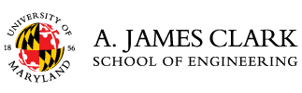

Federal ID # 526002033

**INVOICE**

**UMD Chemical, Materials, and Bioengineering Career Fair**

Thursday, March 7, 2024

3:00 – 6:00 pm

Kim Engineering Rotunda

$100.00

To pay by credit card (with no processing fees) go to <https://quikpayasp.com/umd/commerce_manager/payer.do?orderType=EngineeringCareerServices-ChemicalBioengineering>

Checks should be made payable to the University of Maryland and sent to:

Veronica Perrigan

Engineering Career Services

University of Maryland

1131 Martin Hall

College Park, MD  20742

301-405-3862

[vperriga@umd.edu](mailto:vperriga@umd.edu)